**Module 2 Assignment: Exploring JavaScript Topics with EJS, Node.js, and Express**

Ganavi Hemachandra

Department of Information Technology, Arizona State University

IFT 498/554: Middleware Programming & Database Security

Prof. Dinesh Sthapit

September 03, 2023

**Module 2 Assignment: Exploring JavaScript Topics with EJS, Node.js, and Express**

Initializing a new Node.js project:

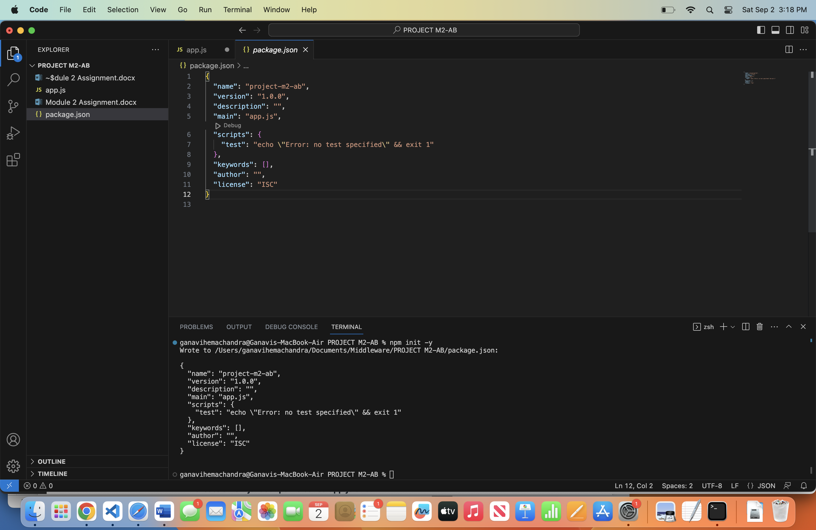

{

"name": "project-m2-ab",

"version": "1.0.0",

"description": "",

"main": "app.js",

"scripts": {

"test": "echo \"Error: no test specified\" && exit 1"

},

"keywords": [],

"author": "",

"license": "ISC"

}

Installing necessary packages:

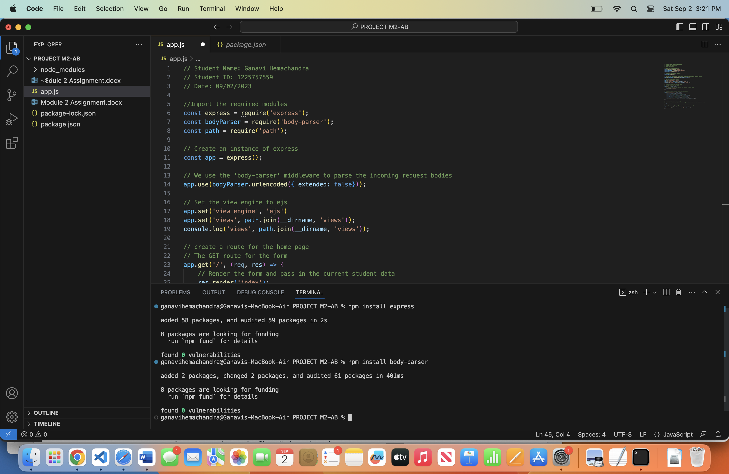

ganavihemachandra@Ganavis-MacBook-Air PROJECT M2-AB % npm install express

added 58 packages, and audited 59 packages in 2s

8 packages are looking for funding

run `npm fund` for details

found 0 vulnerabilities

ganavihemachandra@Ganavis-MacBook-Air PROJECT M2-AB % npm install body-parser

added 2 packages, changed 2 packages, and audited 61 packages in 401ms

8 packages are looking for funding

run `npm fund` for details

found 0 vulnerabilities

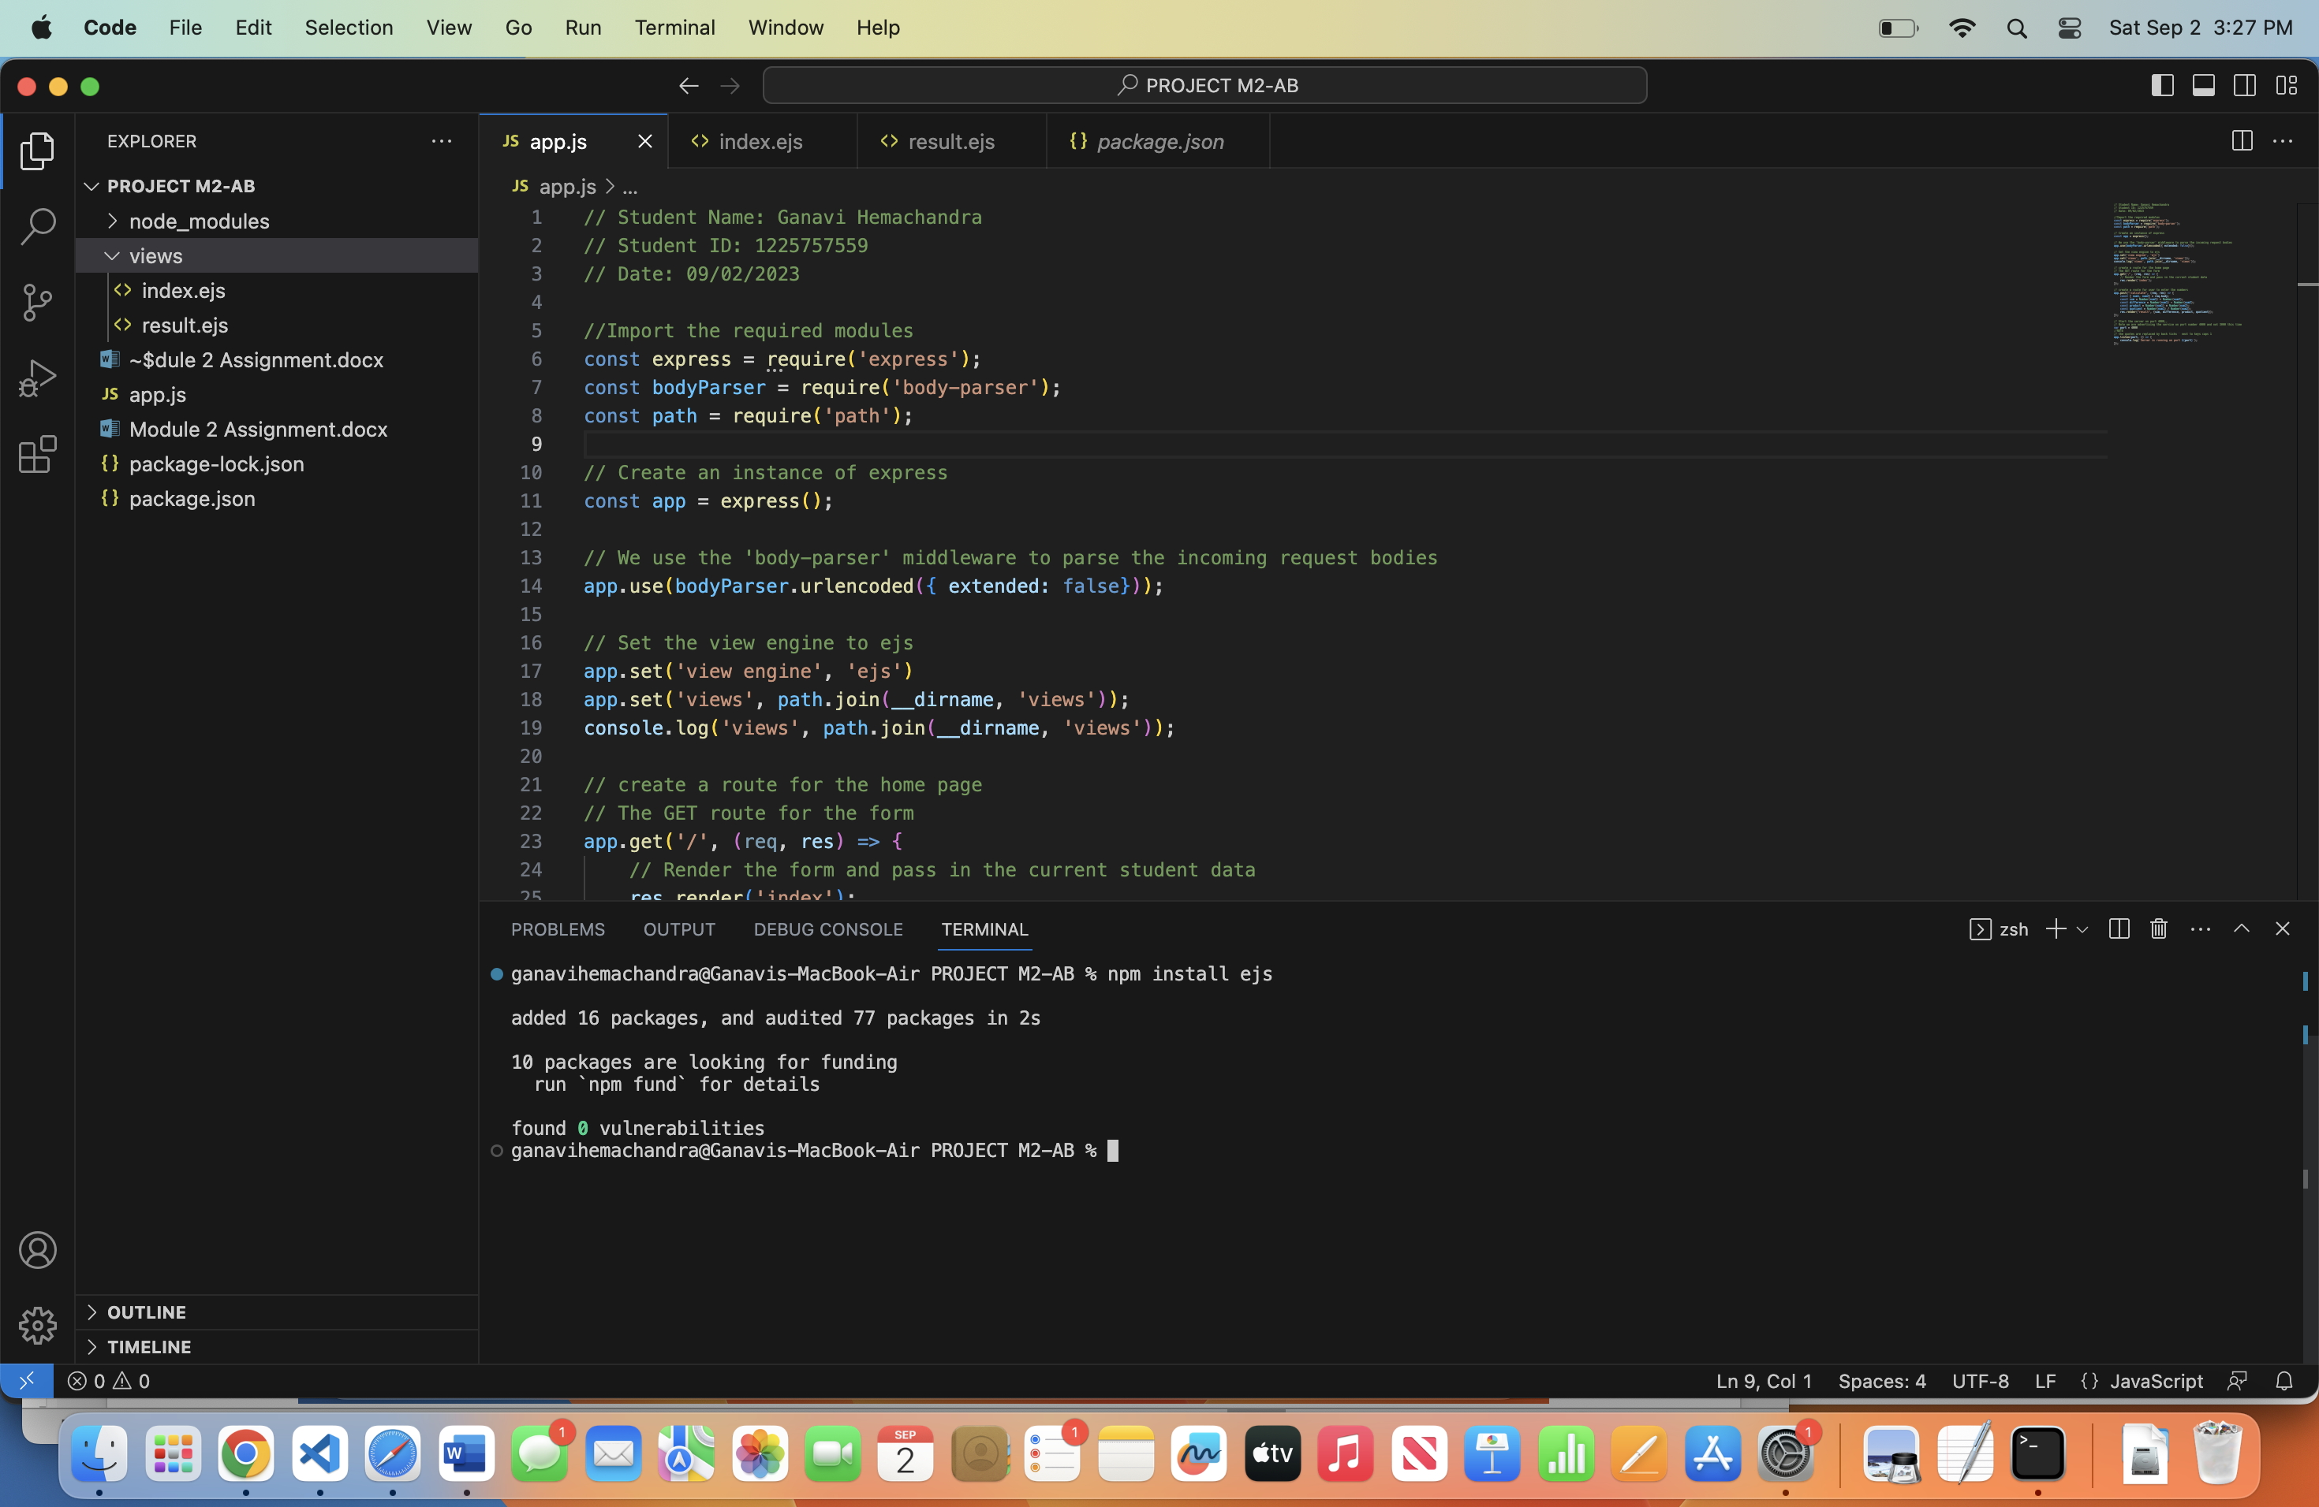

ganavihemachandra@Ganavis-MacBook-Air PROJECT M2-AB % npm install ejs

added 16 packages, and audited 77 packages in 2s

10 packages are looking for funding

run `npm fund` for details

found 0 vulnerabilities

Code:

// Student Name: Ganavi Hemachandra

// Student ID: 1225757559

// Date: 09/02/2023

//Import the required modules

const express = require('express');

const bodyParser = require('body-parser');

const path = require('path');

// Create an instance of express

const app = express();

// We use the 'body-parser' middleware to parse the incoming request bodies

app.use(bodyParser.urlencoded({ extended: false}));

// Set the view engine to ejs

app.set('view engine', 'ejs')

app.set('views', path.join(__dirname, 'views'));

console.log('views', path.join(__dirname, 'views'));

// create a route for the home page

// The GET route for the form

app.get('/', (req, res) => {

// Render the form and pass in the current student data

res.render('index');

});

// create a route for user to enter the numbers

app.post("/calculate", (req, res) => {

const { num1, num2} = req.body;

const sum = Number(num1) + Number(num2);

const difference = Number(num1) - Number(num2);

const product = Number(num1) * Number(num2);

const quotient = Number(num1) / Number(num2);

res.render("result", {sum, difference, product, quotient});

});

// Start the server on port 4000,,

// Note we are advertising the service on port number 4000 and not 3000 this time

var port = 4000

//NOTE

// the quotes are replaced by back ticks ` next to keys caps 1

app.listen(port, () => {

console.log(`Server is running on port ${port}`);

});

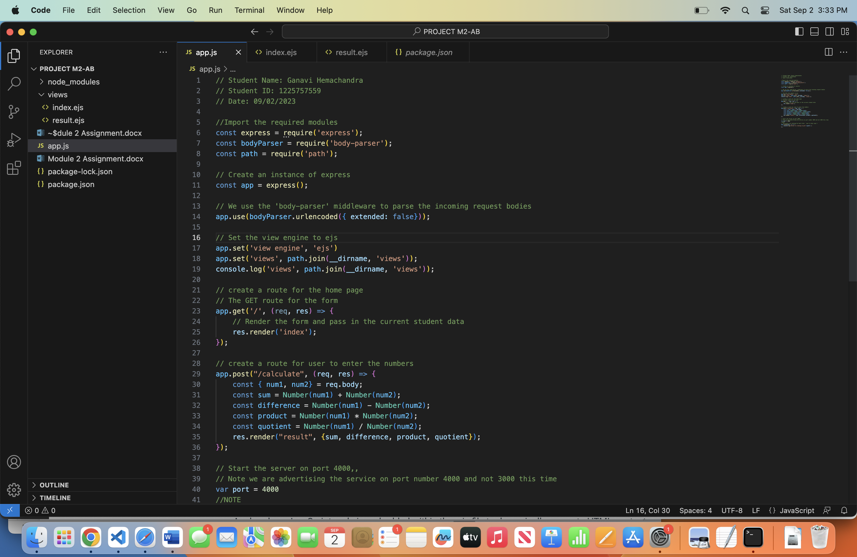

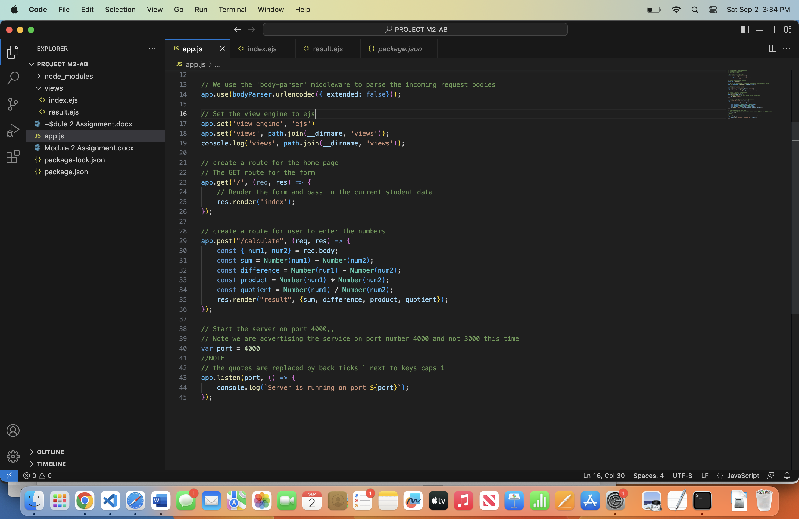

Code for index.ejs:

<!-- Student Name: Ganavi Hemachandra

Student ID: 1225757559

Date: 09/02/2023 -->

<!DOCTYPE html>

<html lang="en">

<head>

<meta charset="UTF-8">

<meta name="viewport" content="width=device-width, initial-scale=1.0">

<title>Document</title>

</head>

<body>

<form action="/calculate" method="POST">

<input type="number" name="num1" placeholder="Enter first number" required>

<input type="number" name="num2" placeholder="Enter second number" required>

<button type="submit">Calculate</button>

</form>

</body>

</html>

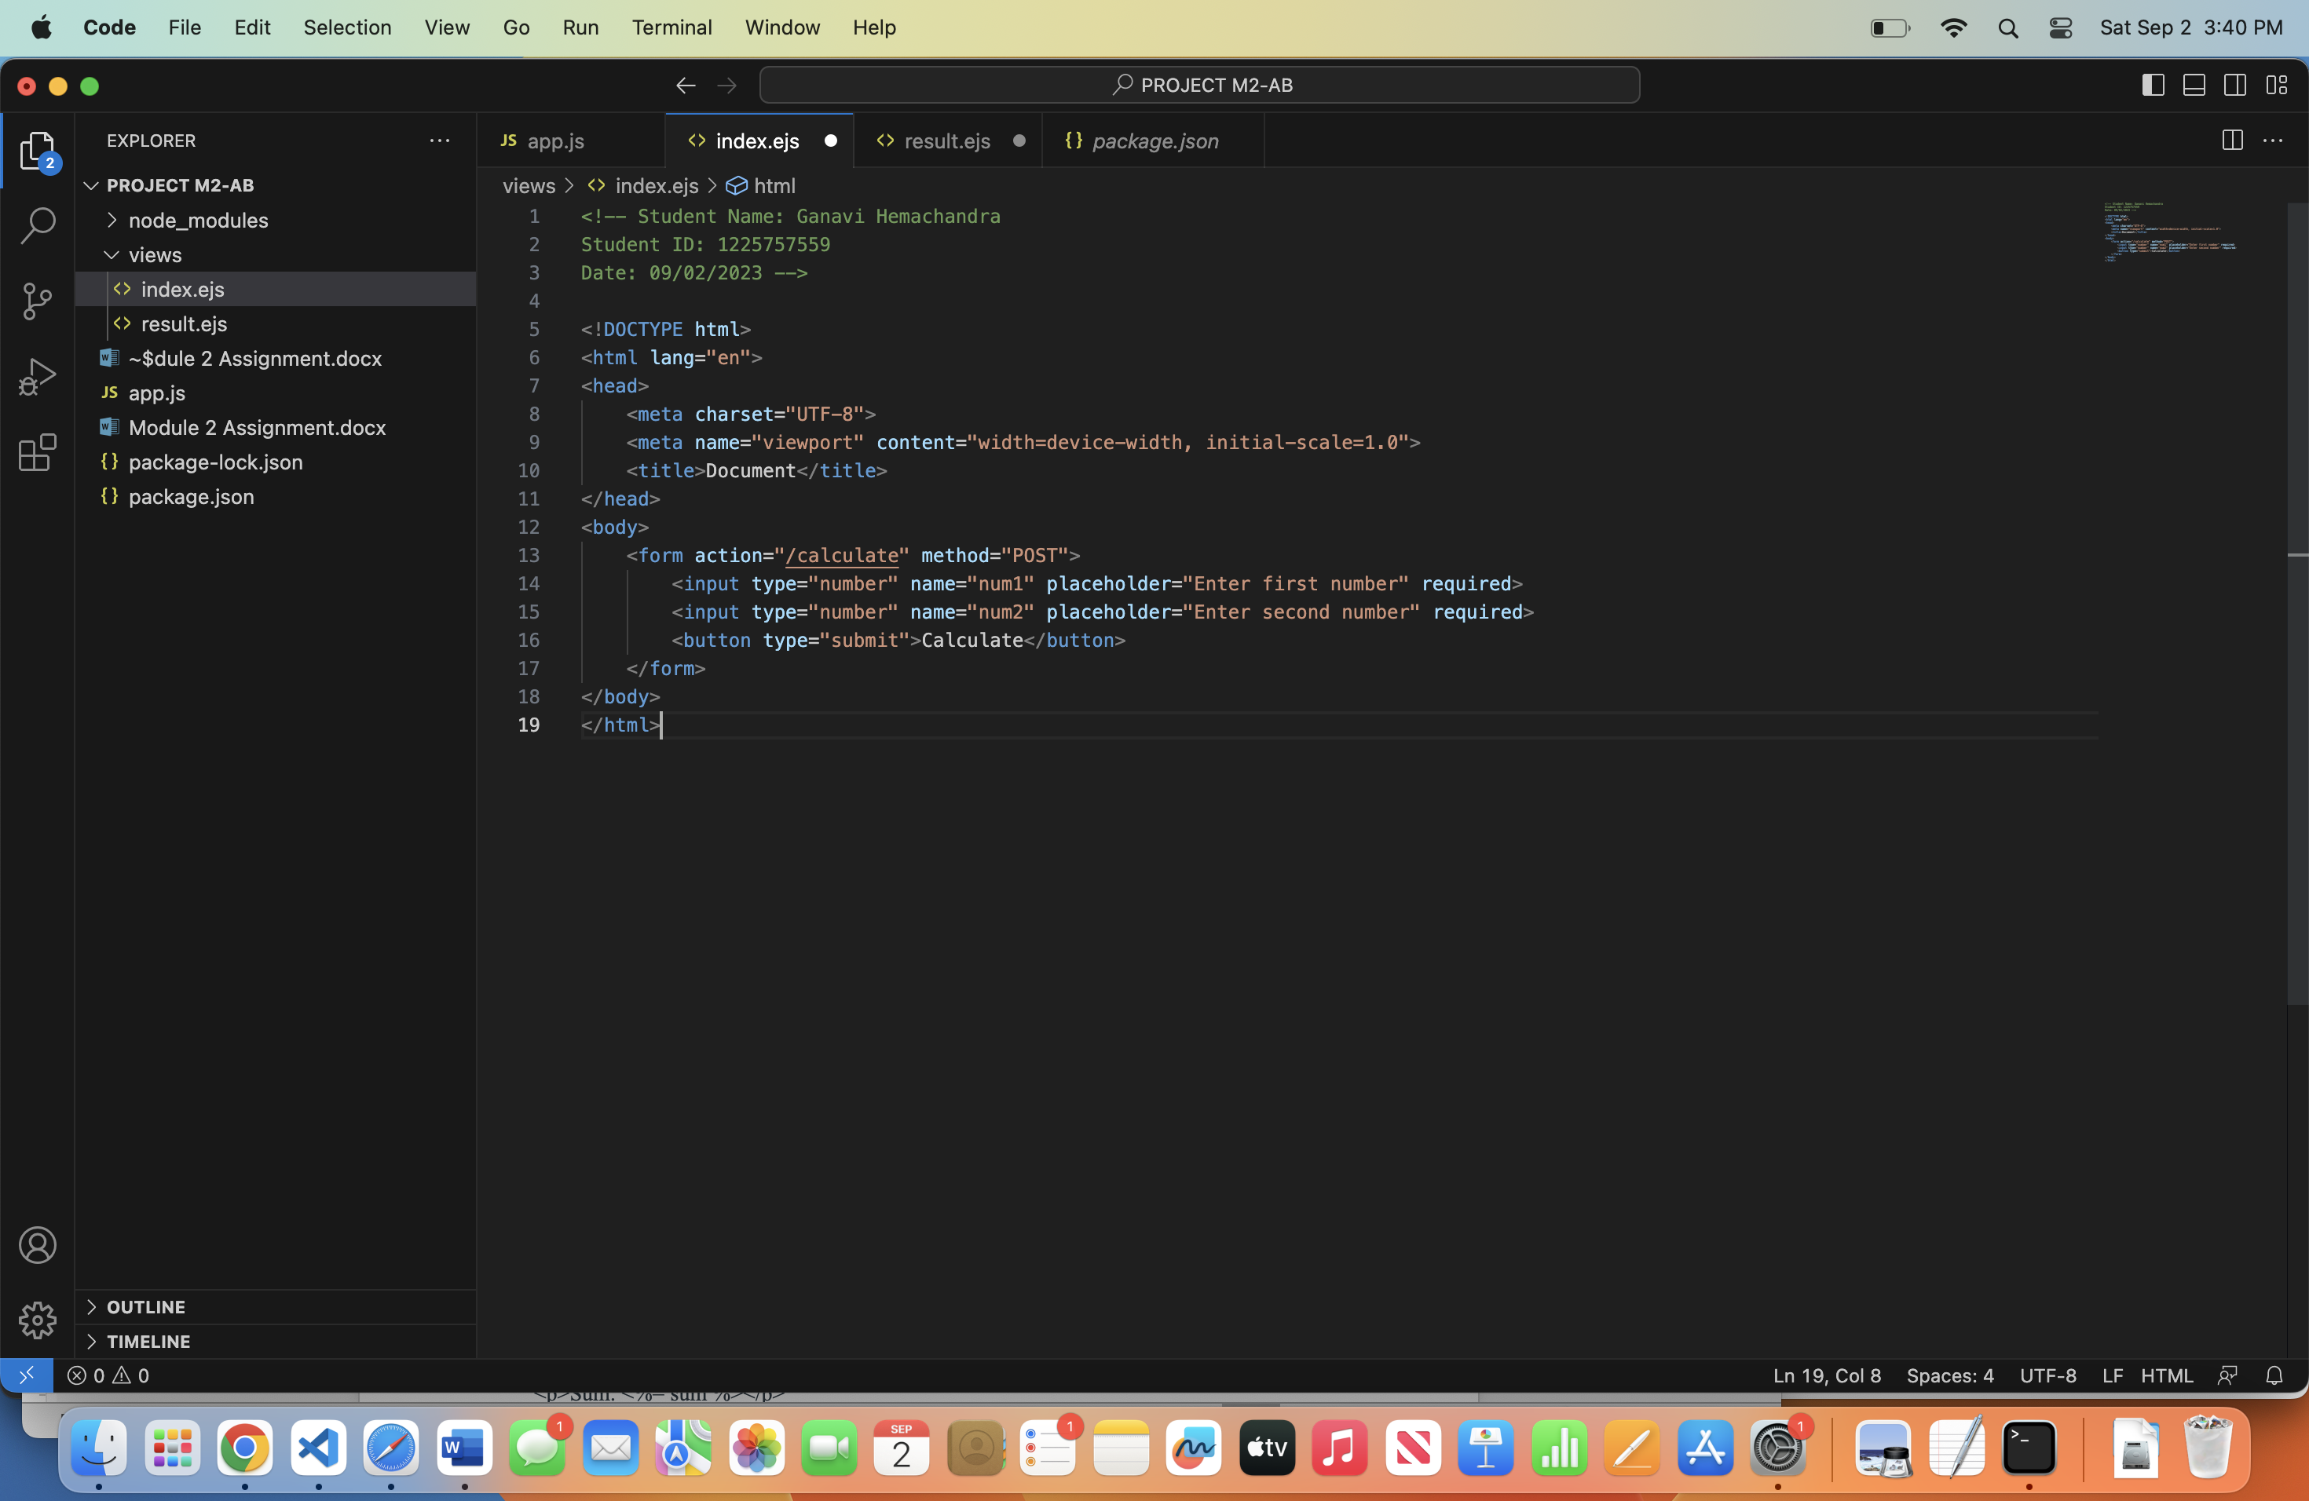

Code for result.ejs:

<!-- Student Name: Ganavi Hemachandra

Student ID: 1225757559

Date: 09/02/2023 -->

<!DOCTYPE html>

<html lang="en">

<head>

<meta charset="UTF-8">

<meta name="viewport" content="width=device-width, initial-scale=1.0">

<title>Document</title>

</head>

<body>

<form action="/calculate" method="POST">

<input type="number" name="num1" placeholder="Enter first number" required>

<input type="number" name="num2" placeholder="Enter second number" required>

<button type="submit">Calculate</button>

</form>

<p>

<h1>Calculation Results:</h1>

<p>Sum: <%= sum %></p>

<p>Difference: <%= difference %></p>

<p>Product: <%= product %></p>

<p>Quotient: <%= quotient %></p>

</p>

</body>

</html>

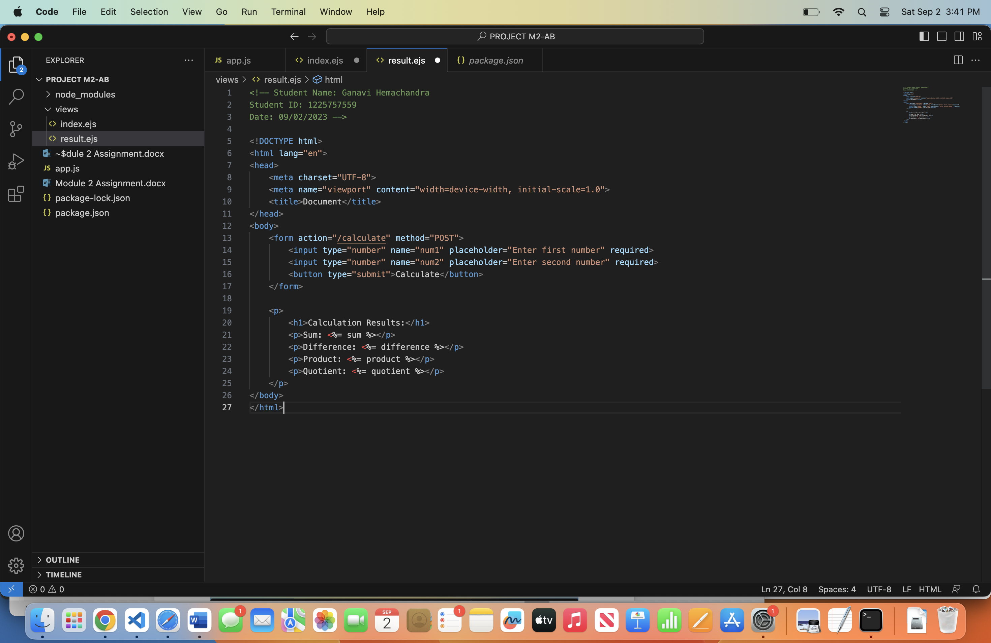

Output page:

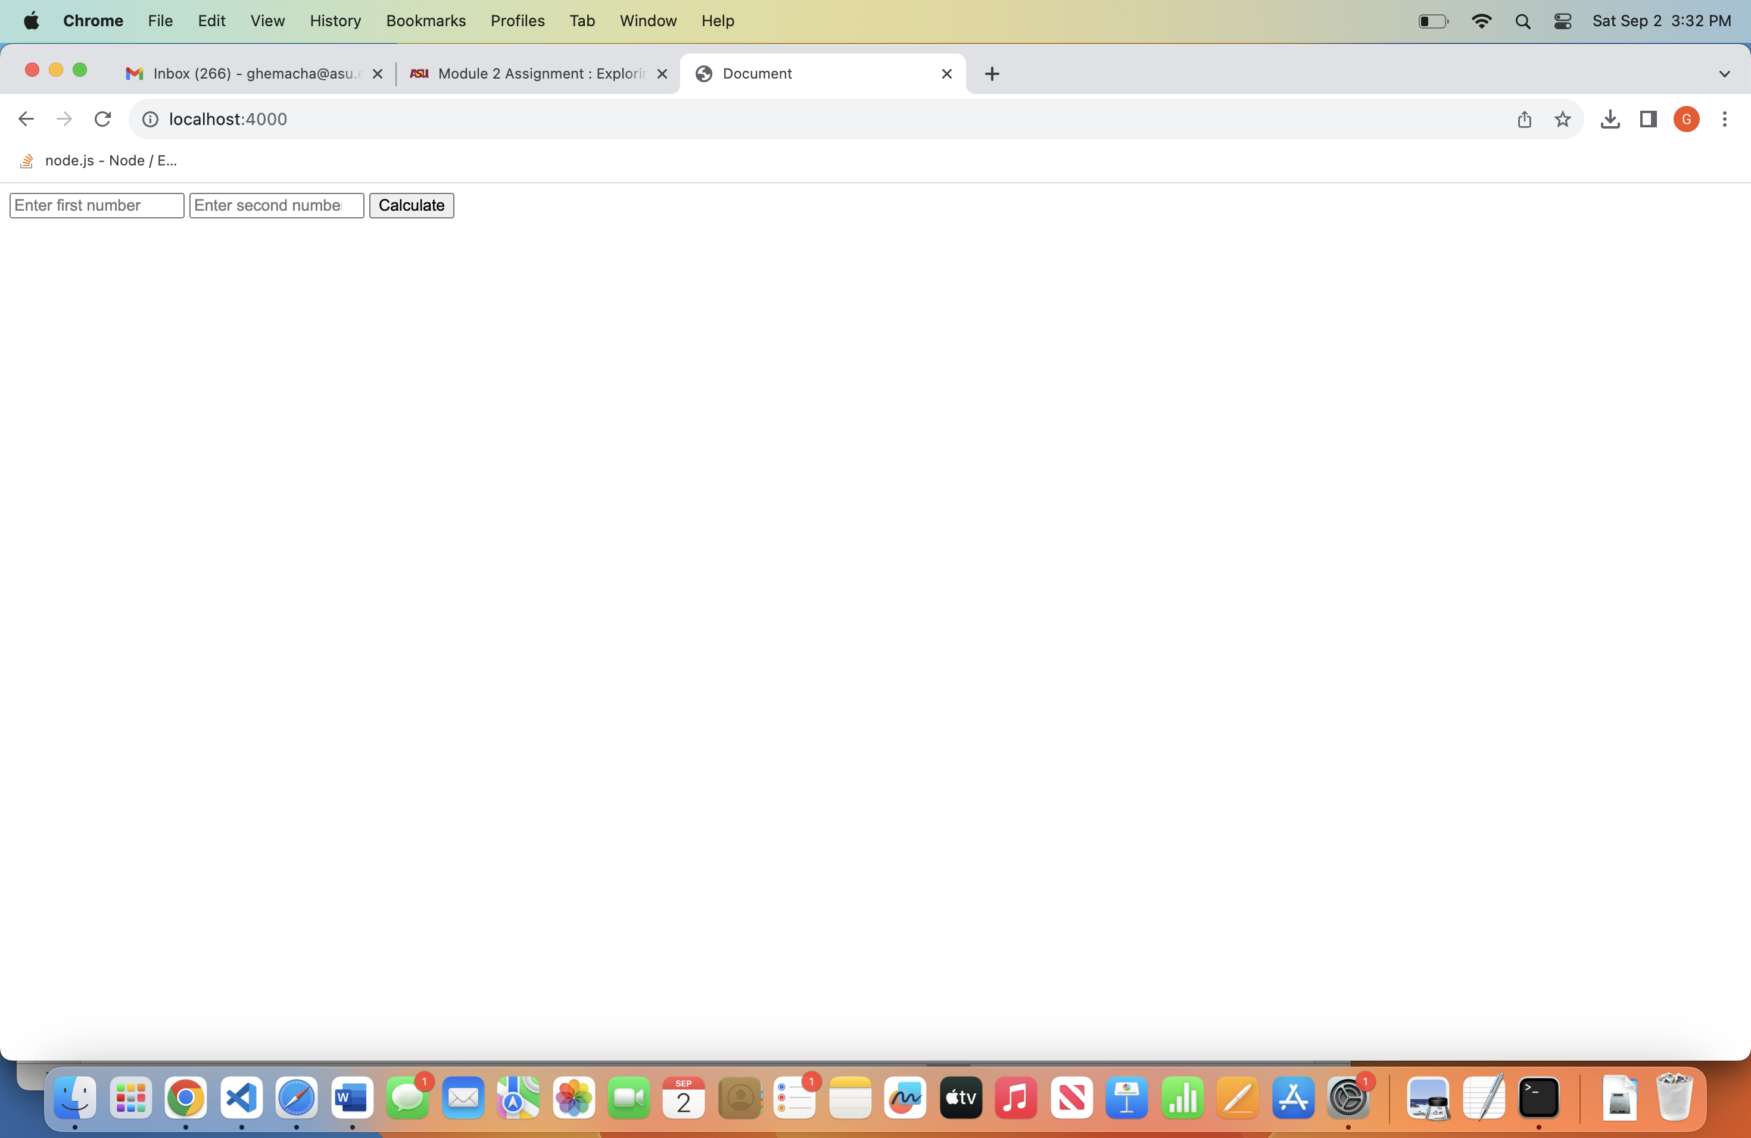

Calculation Results:

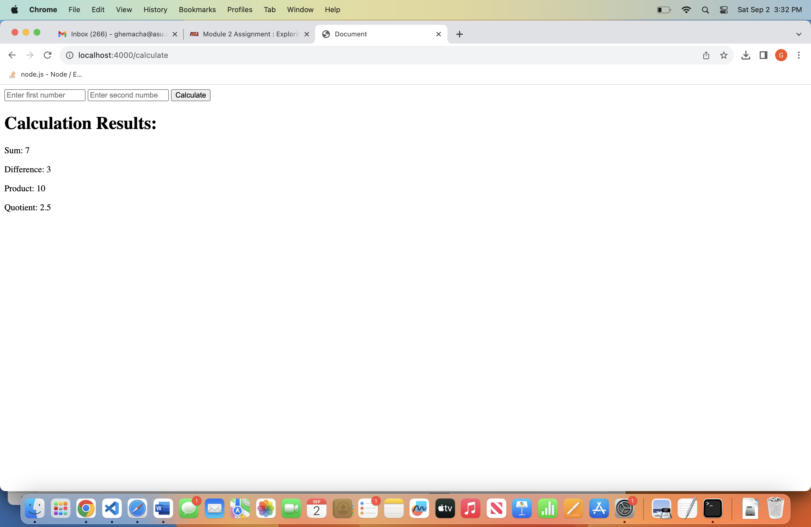

**Original index.ejs code:**

<!-- Student Name: Ganavi Hemachandra

Student ID: 1225757559

Date: 09/02/2023 -->

<!DOCTYPE html>

<html lang="en">

<head>

<meta charset="UTF-8">

<meta name="viewport" content="width=device-width, initial-scale=1.0">

<title>Document</title>

</head>

<body>

<form action="/calculate" method="POST">

<input type="number" name="num1" placeholder="Enter first number" required>

<input type="number" name="num2" placeholder="Enter second number" required>

<button type="submit">Calculate</button>

</form>

</body>

</html>

View page source on the browser:

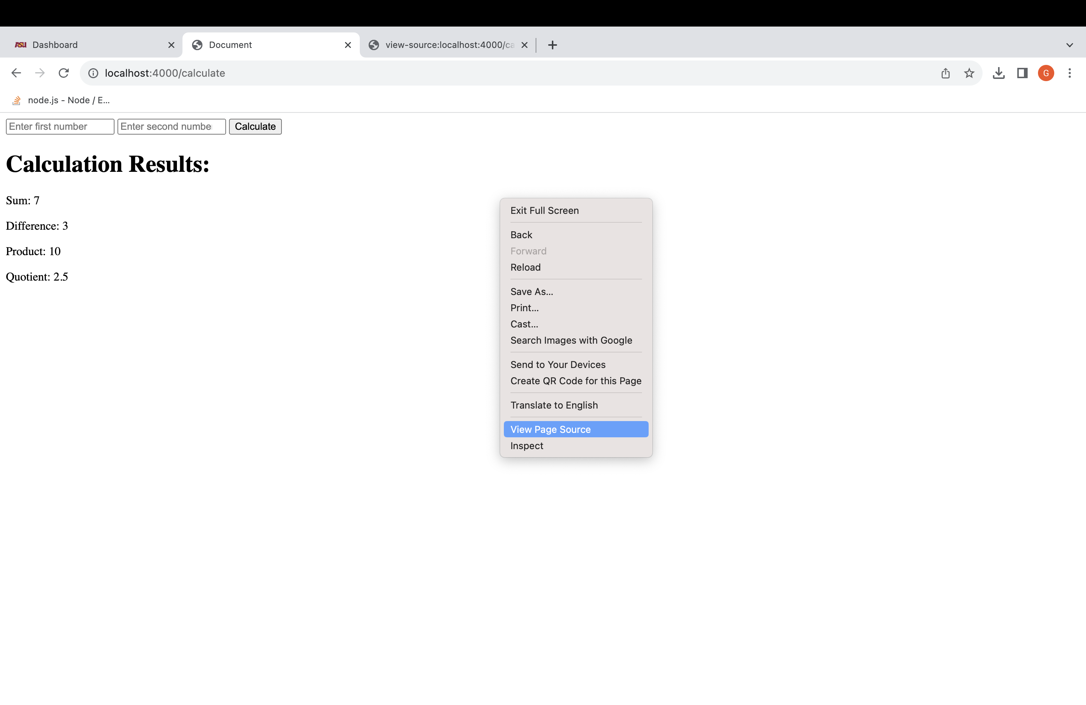

**Assignment: Analyzing .ejs Code vs. HTML Rendered in the Browser**

**.ejs Code Analysis**

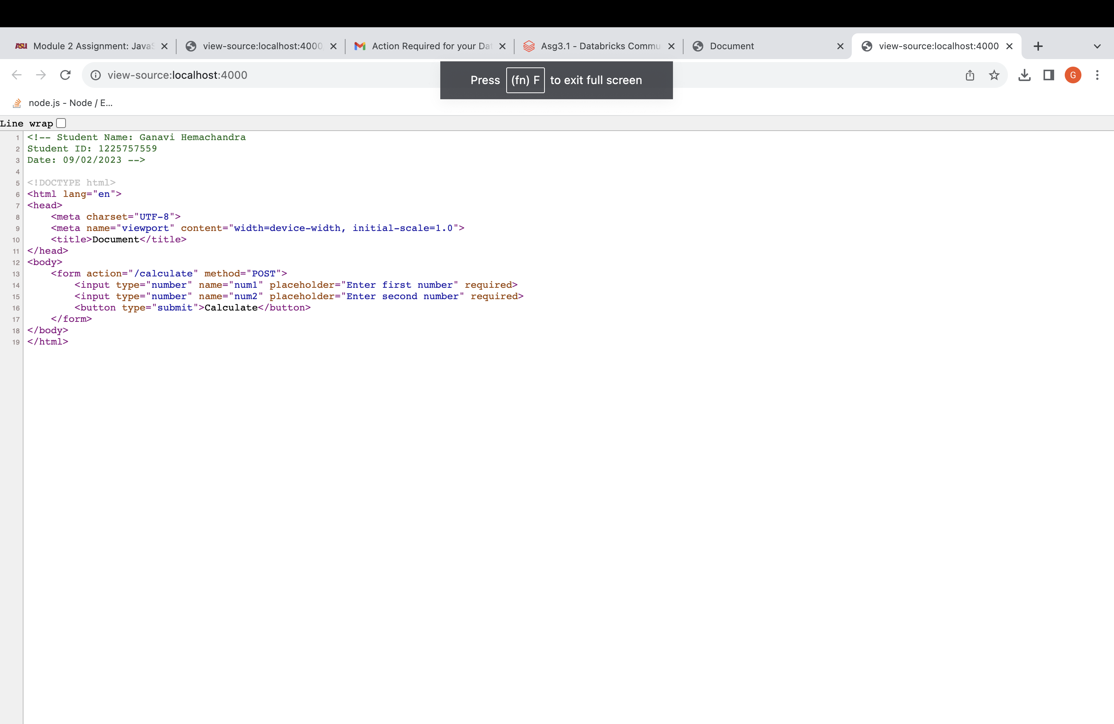

1. Input Form: Users provide two numbers (num1 and num2) in an HTML form.
2. Form Submission: When the form is submitted, the data is sent to the "/Calculate" route on the server.
3. Calculations: On the server, calculations (sum, difference, product, quotient) are performed using the provided numbers.
4. Display Results: The calculation results are then displayed in the "result.ejs" template.

In summary, users enter numbers, submit the form, calculations are done on the server, and the results are shown in "result.ejs." There's no dynamic JavaScript altering the HTML in this code.

Rendered HTML on browser:

<form action="/calculate" method="POST">

<input type="number" name="num1" placeholder="Enter first number" required>

<input type="number" name="num2" placeholder="Enter second number" required>

<button type="submit">Calculate</button>

</form>

There's no dynamic JavaScript altering the HTML in this code.

**Original result.ejs Code:**

<h1>Calculation Results:</h1>

<p>Sum: <%= sum %></p>

<p>Difference: <%= difference %></p>

<p>Product: <%= product %></p>

<p>Quotient: <%= quotient %></p>

**.ejs code analysis:**

1. Dynamic HTML Generation: The .ejs file showcases how to use JavaScript code within HTML templates to generate dynamic content. The code enclosed in `<% %>` tags indicates that it will run on the server before sending HTML to the browser.
2. Variable Insertion: Variables like sum, difference, product, and quotient are included in the HTML template using the `<%= variableName %>` syntax. This syntax acts as a placeholder for dynamic values.
3. Control Structures: This file doesn't include explicit control structures such as loops or conditionals. Its main purpose is to render dynamic content, not to perform complex logic.
4. EJS-Specific Syntax: EJS-specific syntax is utilized, notably `<%= %>` for inserting variables and `<% %>` for embedding JavaScript code.

In essence, this .ejs file demonstrates how to incorporate JavaScript for dynamic content within HTML templates using EJS-specific syntax, without involving complex control structures.

Rendered HTML browser:

<h1>Calculation Results:</h1>

<p>Sum: 7</p>

<p>Difference: 3</p>

<p>Product: 10</p>

<p>Quotient: 2.5</p>

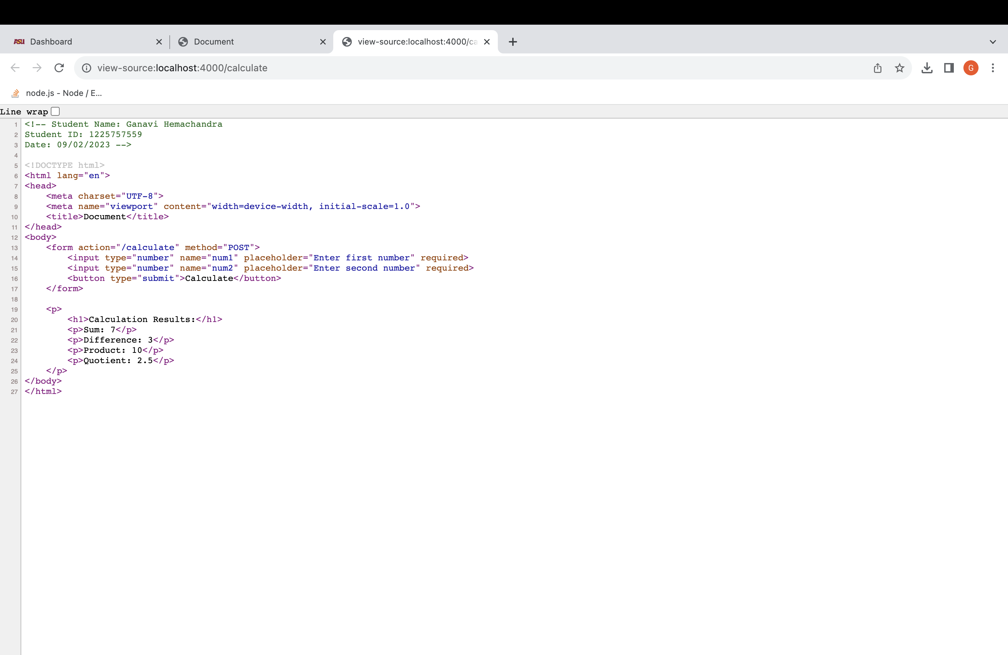

HTML Code Analysis:

1. Preserved HTML Comments: HTML comments like "name," "ASU ID," and "date" in the .ejs code remain unchanged in the rendered HTML. EJS does not process these comments; they are static content.
2. Variable Replacement: In the rendered HTML, placeholders like `<%= sum %>`, `<%= difference %>`, `<%= product %>`, and `<%= quotient %>` are replaced with actual values:

- `<%= sum %>` is replaced with 7.

- `<%= difference %>` is replaced with 3.

- `<%= product %>` is replaced with 10.

- `<%= quotient %>` is replaced with 2.5.

1. Static HTML Tags: Static HTML elements such as headings, paragraphs, and anchor tags are preserved in the template. The HTML structure remains consistent between the original .ejs code and the rendered HTML. This illustrates how EJS facilitates dynamic content generation within an HTML template while preserving static elements.

Certainly, let's simplify the benefits and scenarios for using .ejs templates:

**Benefits of .ejs:**

1. Dynamic Information: EJS templates let you add changing content to web pages, making them more engaging and tailored to users.
2. Cleaner Code: EJS helps you write neater and more maintainable code by eliminating the need to mix JavaScript values with HTML.
3. Efficient Updates: When data changes, you only modify the dynamic content in the template instead of recreating the whole page.
4. Reuse Code: EJS separates your webpage's structure from the changing data, allowing you to apply the same design to different content.

**Scenarios:**

1. Real-Time Updates: When used with front-end frameworks, EJS templates help build real-time applications with live, dynamic updates.
2. Data-Driven Websites: EJS templates are ideal for websites that display data from sources like databases, APIs, or user inputs.

**Optional Enhancement (Bonus):**

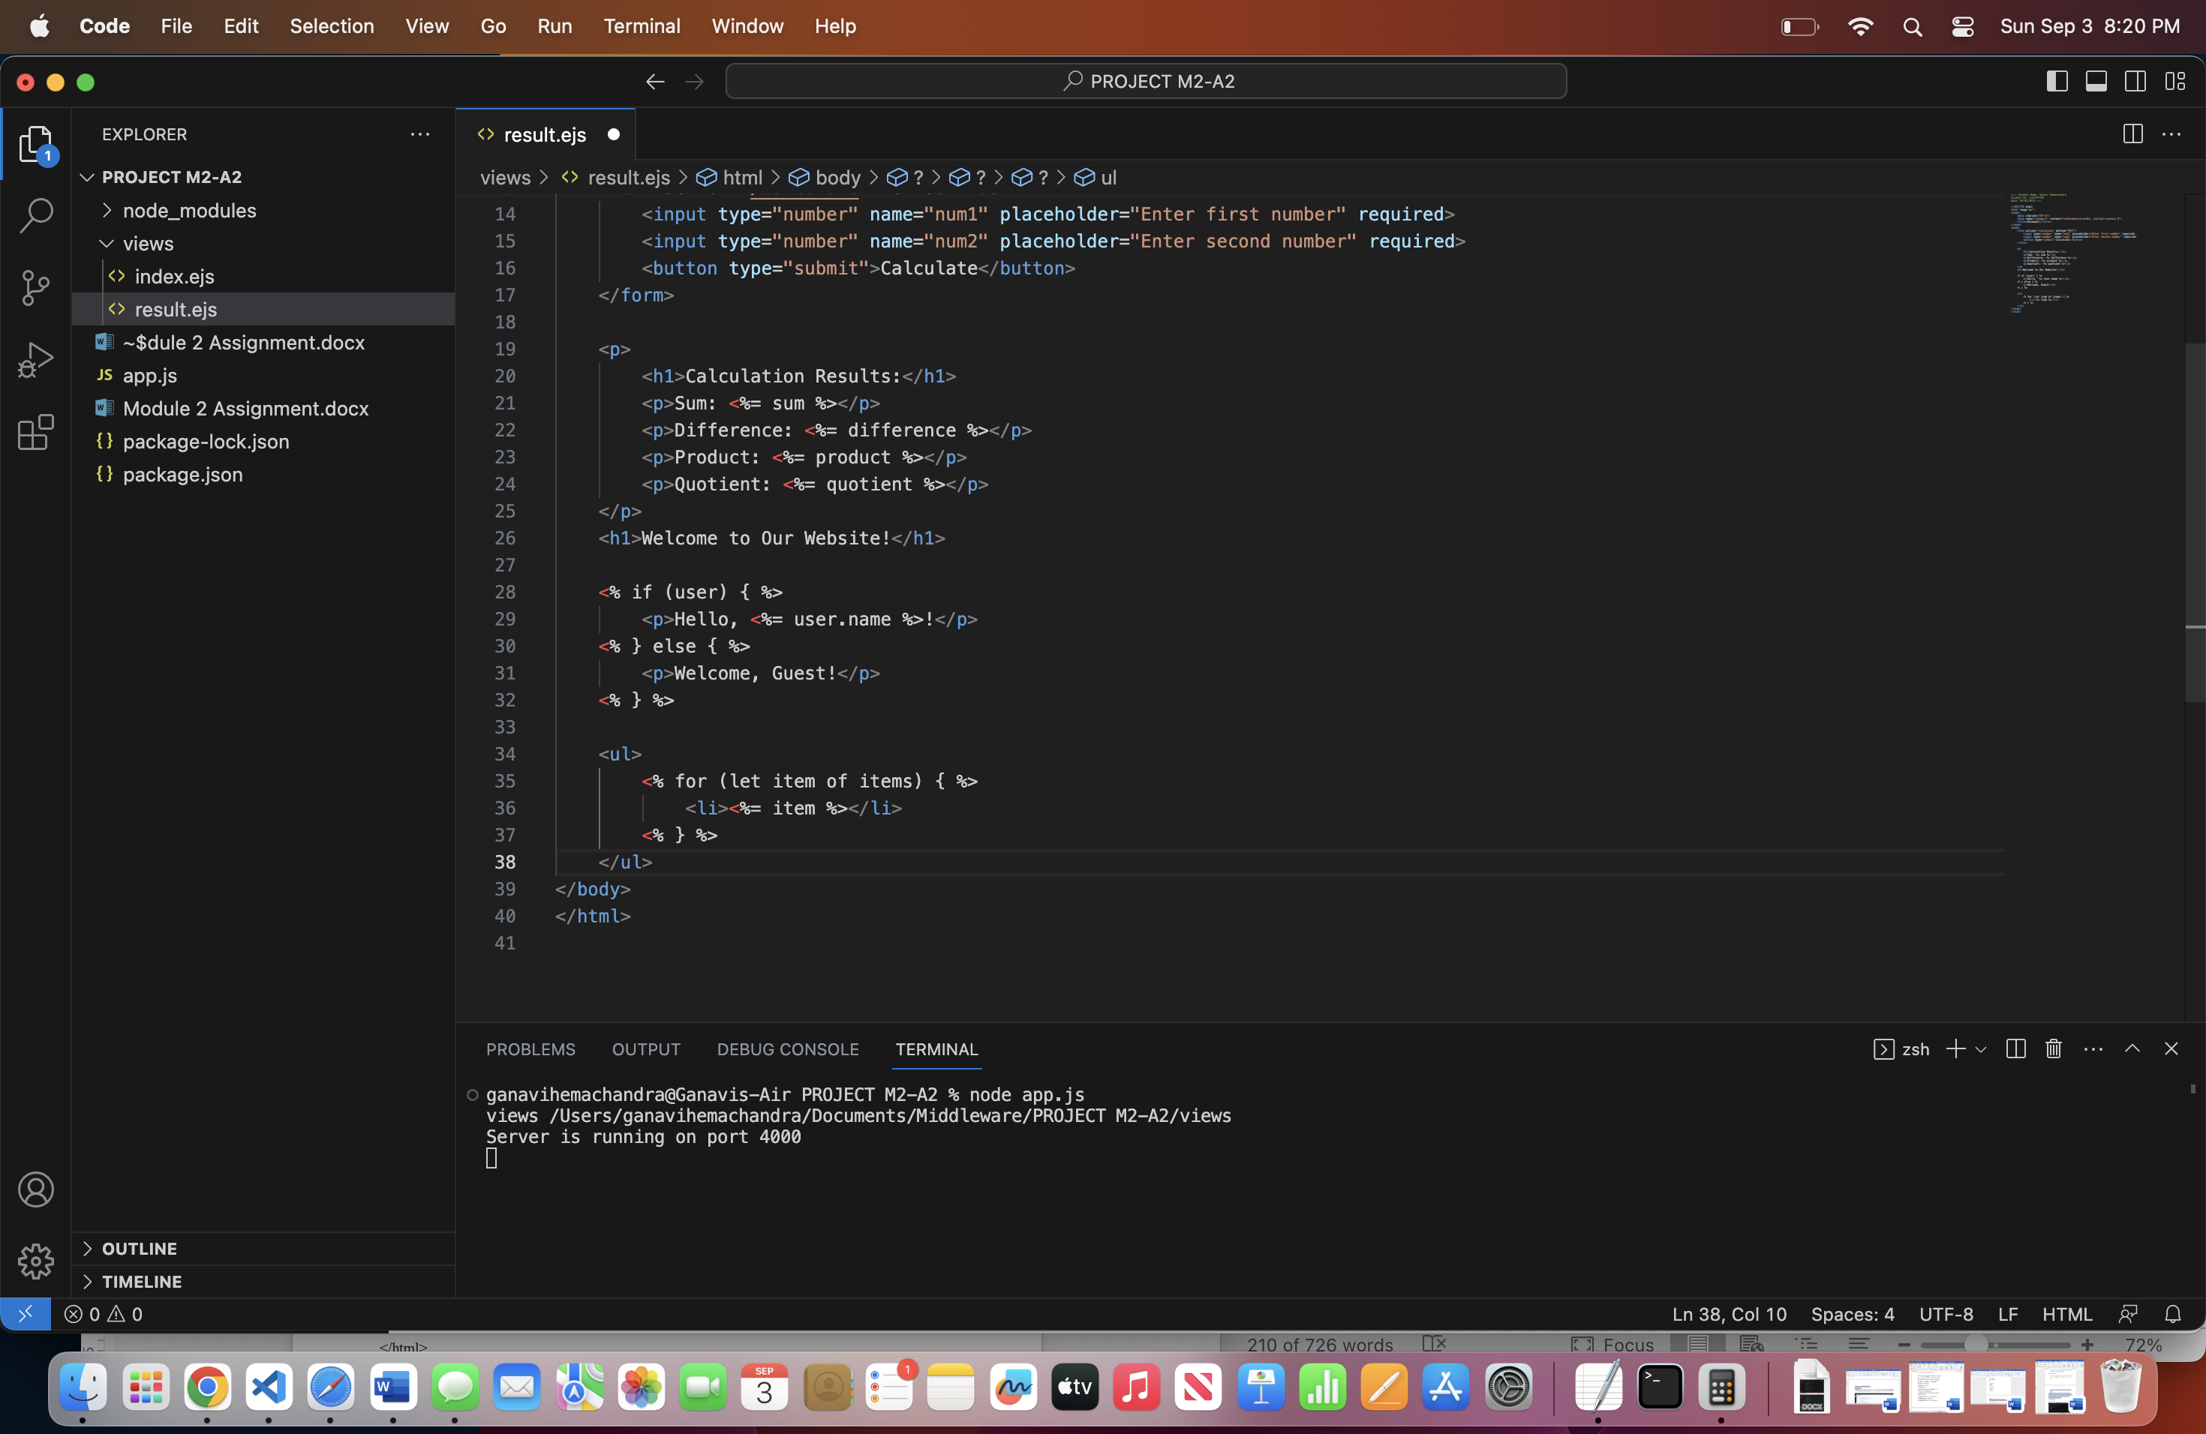

We've introduced conditional rendering: If a user object is provided, it displays a personalized greeting with the user's name. Otherwise, it welcomes the guest.

We're iterating over an array called "items" and creating a list item for each element in the array.

Github Link:

<https://github.com/ghemacha22/Middleware-Programming-Database-Security>

